**ASSIGNMENT 3.3**

1. **Write a program to find out the max number from given array using function.**

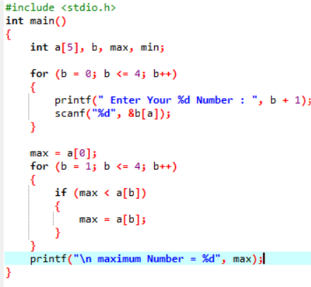

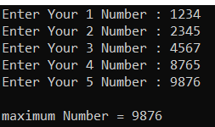

1. **WAP of Addition, Subtraction, Multiplication and Division using Switch case.(Must Be Menu Driven).**

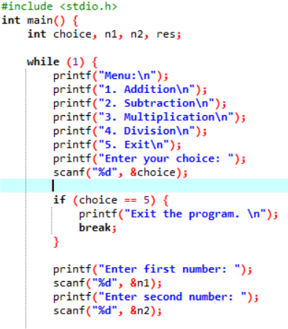

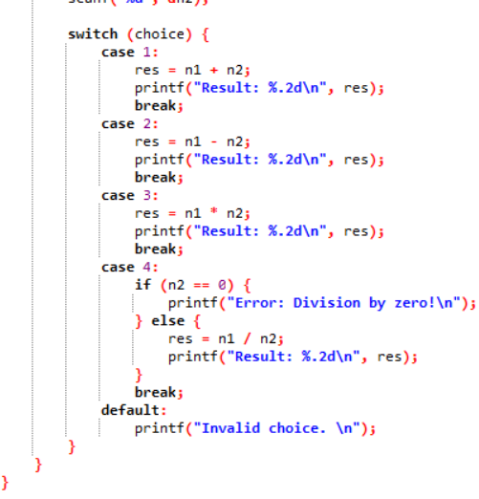

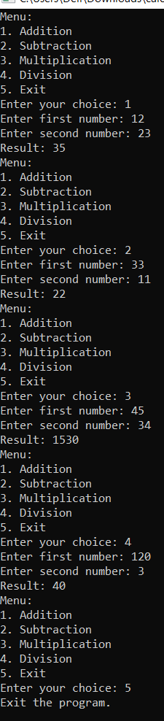

1. **WAP to find reverse of string using recursion.**

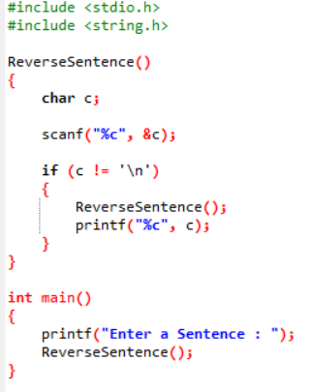



1. **WAP to find factorial using recursion.**

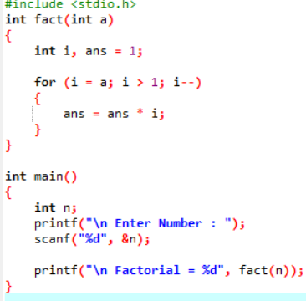

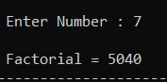

1. **WAP to take two Array input from user and sort them in ascending or descending order as per user’s choice.**

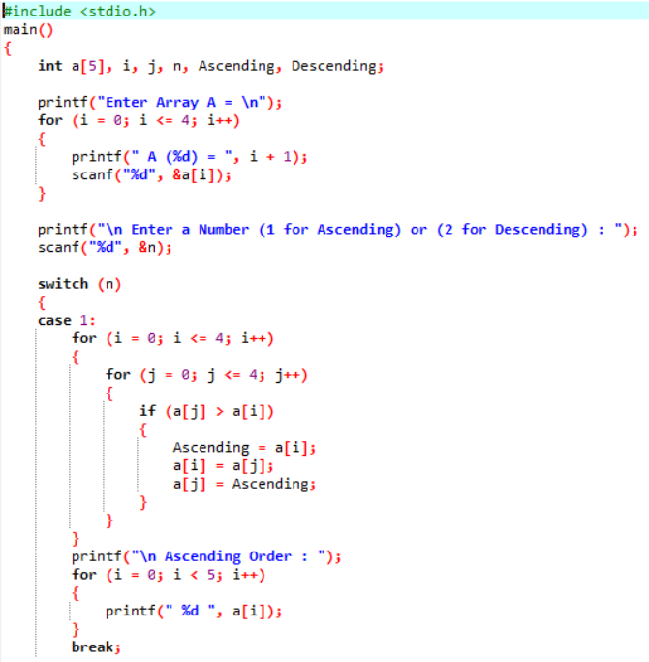

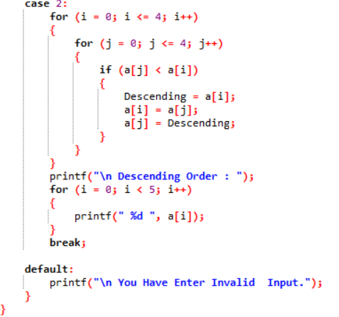

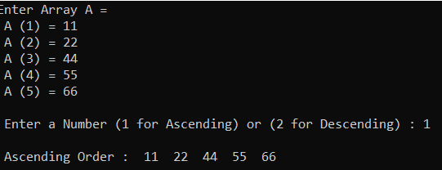

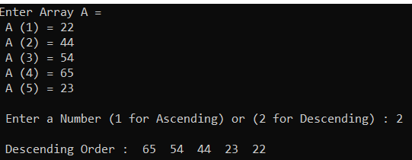

1. **WAP to make addition, Subtraction and multiplication of two matrix using 2-D Array**

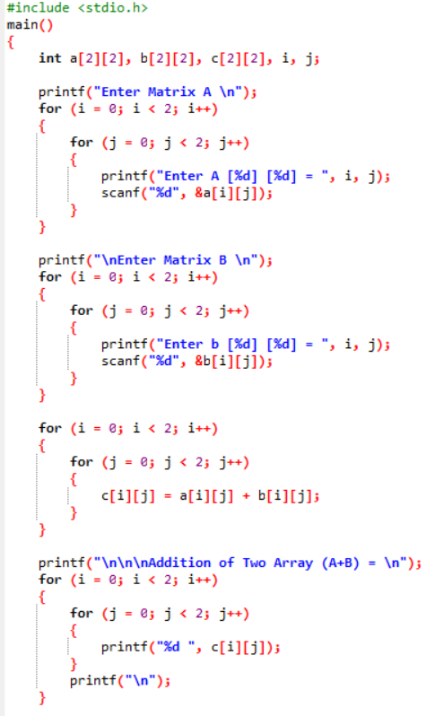

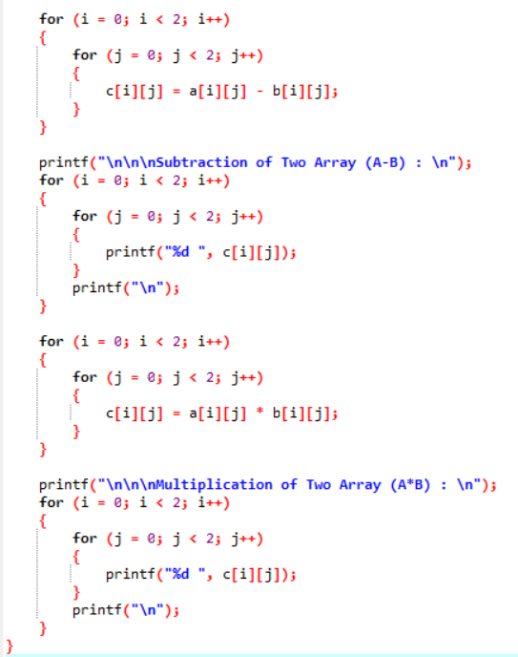

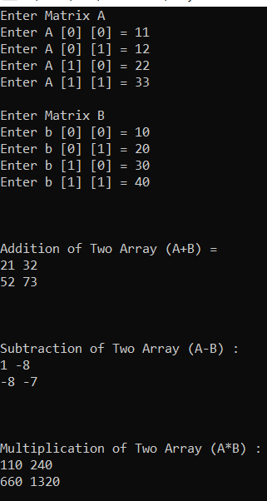

1. **WAP Find out length of string without using inbuilt function.**

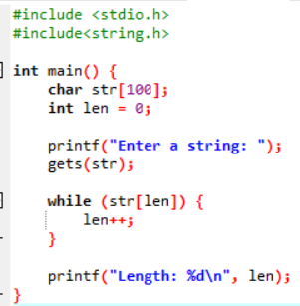



1. **WAP to reverse a string and check that the string is palindrome or not**

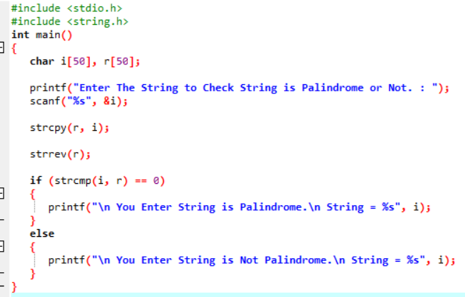

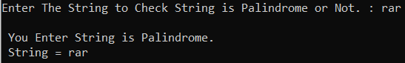

1. **Write a program of structure employee that provides the following information -print and display empno, empname, address and age.**

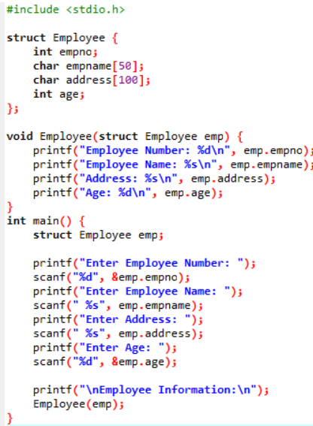

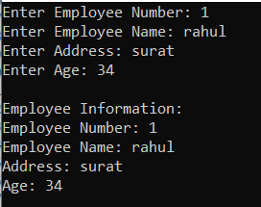

1. **Write a program of structure for five employee that provides the following information -print and display empno, empname, address and age**

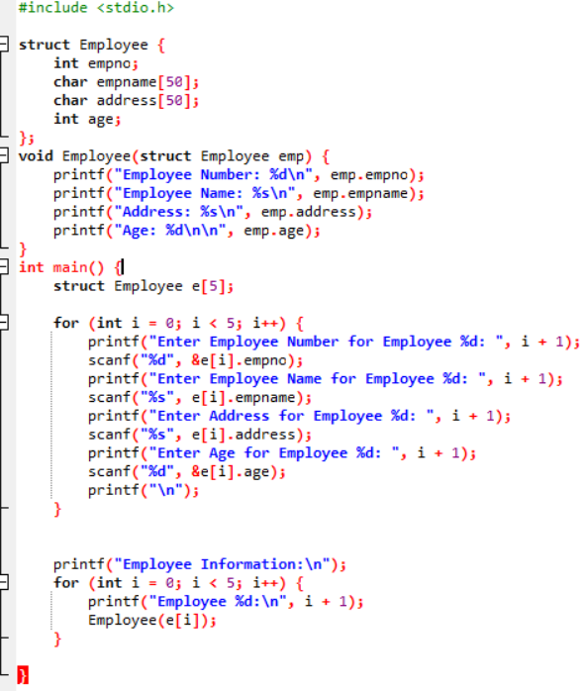

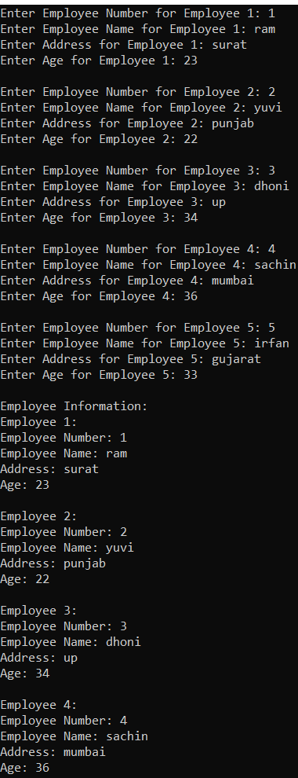

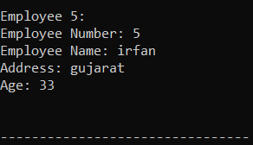

1. **WAP to show difference between Structure and Union.**

**Structure :**

**A structure is a composite data type that groups variables of different data types.**

**Each member of the structure has its own memory location.**

**All members of a structure are allocated memory, and the size of the structure is the sum of the sizes of its members.**

**It's used when you want to access and manipulate each member independently.**

**Example: A structure to represent a person with members for name, age, and address.**

**Union :**

**A union is a composite data type that groups variables of different data types, but it only allocates enough memory to store the largest member.**

**All members share the same memory location, so only one member can hold a value at a time.**

**It's used when you want to save memory and don't need to access multiple members simultaneously.**

**Example: A union to represent a shape that can be either a circle or a rectangle, but it only uses memory for the largest shape.**

**In simple terms, a structure stores all of its members separately, while a union stores only one member at a time, sharing the memory with other members. Structures are used when you need to work with multiple members simultaneously, while unions are used when you want to save memory and work with only one member at a time.**